# VueJS – ToDo List

A workshop created for the course ["VueJS Fundamentals @ Softuni"](https://softuni.bg/trainings/2430/vuejs-fundamentals-july-2019)

Your goal is to implement a **ToDo List** that has the following functionalities

* **Add Item** – Adds a todo item inside a **collection** from an input field (*try implementing it without v-model*).
* **ToDo List** – lists all todo items. Clicking the "**Complete**" button removes the item from the current collection and adds it in completed. Clicking the "**Delete**" button removes the item from the current collection.
* **Completed List** – lists all completed items. Clicking the "**Restore**" button removes the item from the current collection and restores it back to the todo items. Clicking the "**Delete**" button removes the item from the current collection.
* **Navigation** – there are **3 buttons** that load different components.

You're given an archive with **HTML/CSS** resources. Split the application into components and also apply **scoped styling** for some of the components and global styling for all. There is a file called "**tasks.js**" which includes the first 5 initial tasks, load them on creation of that instance.

Use everything you have learned so far like **registering components, passing down props/slots, emitting events, validating prop types, dynamic components** and etc. Also feel free to extend the application as you see fit.

### Add Item

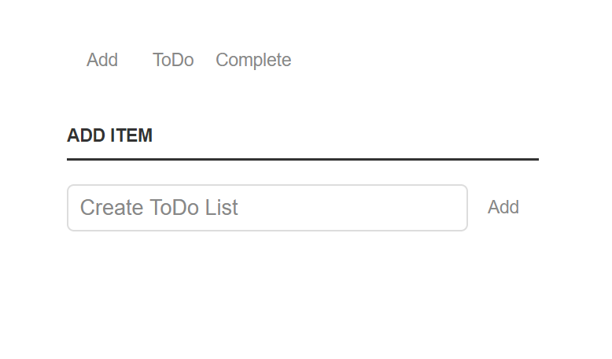

### ToDo List

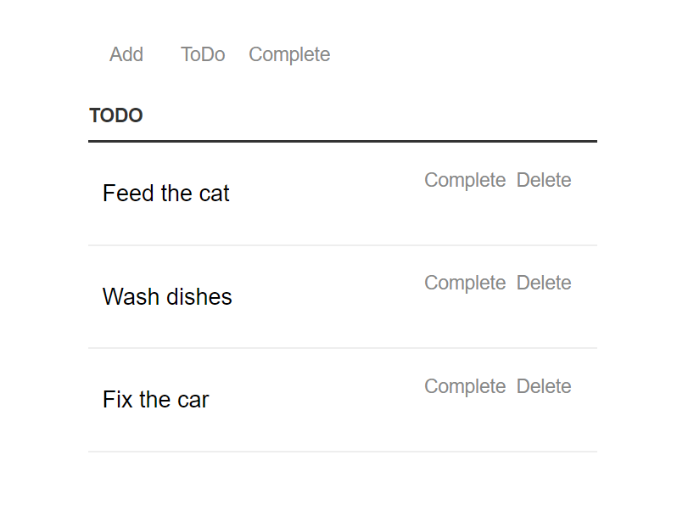

### Completed Tasks

